Match It - Frequently Asked Questions
Why would I want to use Match It?
This really depends on the individual. Here are a number of reasons that might interest you.
Perform a quick “common sense” check of your own analysis.
All calculations performed by Match It are based on real historical data, and all information presented to you is based on events that have happened. Would you be comfortable in your analysis that the market will be going up, if all historical Matches have gone down?
Gives a frame of reference for Risk levels.
The summary screen gives a reference of where price levels have gone when the market has looked similar in the past. You can use these bands to see roughly what risk you might expect if the market behaves the same this time. The outermost shaded areas represent the extreme values seen historically.
Identifies potential opportunities.
Match It is based on historical data, and there is no guarantee that the market will behave the same in future. However, Match It can still identify information such as when historical data indicates a directional bias, and it may be worth spending time to investigate these.

How can I get value from the summary screen?
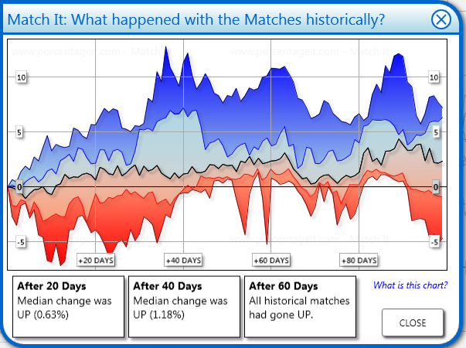
People read the summary screen in different ways. Usually the first thing to do is to look at the three boxes at the bottom which describe what happens after different time periods. These either say “Median change was up/down” – in which case unless the change is very large, there is no significant directional bias in the past data. They can also say “Most (75%) of matches had gone up/down, or even All historical matches had gone up/down”. This shows that the historical Matches had a directional bias, with a reasonable percentage going in that direction. If this occurs, it may be worth investigating if you think that it will be the case this time too.
The second thing to look at is the solid black line, or median line, which is half way through the data. If this is showing a reasonably established trend, and is deviating from the zero line, this shows that the historical Matches did have an underlying directional bias.
The third thing to look at is the width of the bands below and above the median line. In the example picture above, the red band between 40 and 80 days is generally quite close to the median line. The extreme base of the red band shows the total risked amount. You can use the extremities of the bands to estimate the risk associated with a trade direction, potential profitability of a position, or even give you a feel of how long a position will need holding for.
As you get used to the screens, you will pick out more subtleties with them and you may look for other aspects of interest. For example if you have a very wide dark blue or dark red band, that you feel is unrealistic then this may be one extreme Match. If you see this it might be worth going to the Matches view, reviewing if that Match looks reasonable, and if not removing it.
I’ve got a better idea of what Match It does now, and I’d like to see the introduction again.
To launch the introduction tour again, right click anywhere in Match It, and select Properties
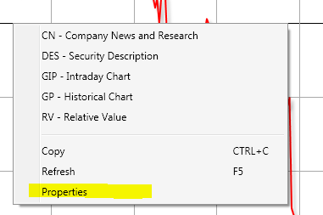
Switch to the troubleshooting tab, and click on “Troubleshooting”, then click on the “Restart Product Tour” button. The product tour will be restarted and displayed immediately.
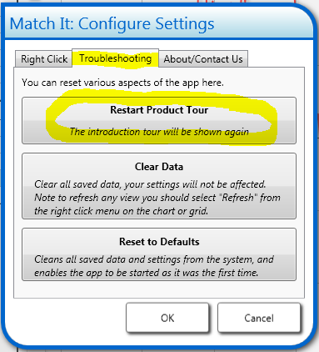

I trade the stocks from the IBOV Index, and I’m only interested in finding Matches from the same market how do I do that?
The answer to this applies to any other Index as well.
You need to change the list of tickers on the left hand side of Match It to be the members of the Index that you trade. In this case the IBOV Index.
From Match It’s main browser view, click on the Add button at the bottom left
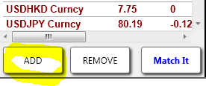
This opens up a window which allows the manipulation of tickers on the list. You can add tickers individually, or in bulk from some other source such as your portfolios (PRTU). In addition you can add members of specific Indexes.
Select Index Members at the top
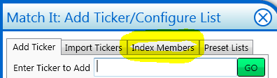
You will then have the option of entering an Index, and a number of members from the Index
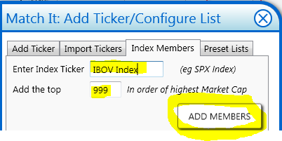
Set the number next to “Add the top” to be large (eg 999) above to include all members. Note that the more tickers you include in Match It, the longer calculations will take, so we default to 50 tickers.
Once you’ve entered a valid ticker and a number, hit “ADD MEMBERS”.
A dialog similar to the following will be shown:
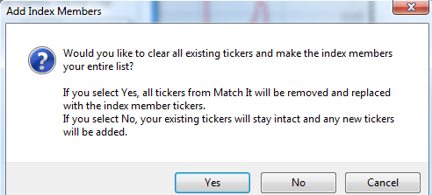
This is asking if you want to keep any tickers you already had, or if you want to only use the IBOV Index tickers. As you’re only interested in Matches from the same market, hit Yes.
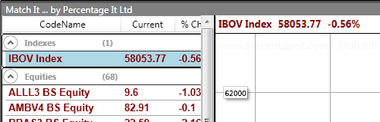
Match It has now loaded with just the IBOV Index Members, and any Matches will only look at those members.

I’m interested in comparing the DAX Index ticker against other Indices, how do I do this?
To do this, you need to reset your list to a list of all the Indices you want to look at. Fortunately, Match It has a preset list which is a good template to start from here.
From Match It’s main browser view, click on the Add button at the bottom left
This opens up a window which allows the manipulation of tickers on the list. You can add tickers individually, or in bulk from some other source such as PRTU. In addition you select preconfigured lists, and these are the ones you are given the option of selecting the very first time you launch Match It.
Select Preset Lists at the top
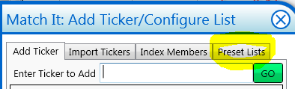
Choose the “Small List” – described as a small selection of Indexes
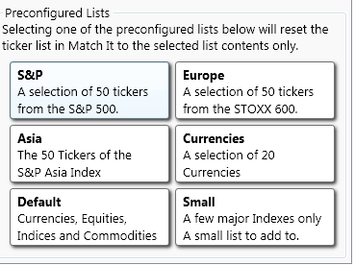
You will see a message similar to this:
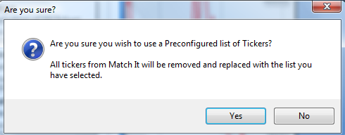
This is just checking that you want to replace your current ticker list with the preconfigured list of major Indexes. Hit Yes, and your list will be changed automatically.
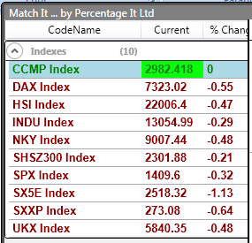
You now have a default list of 10 Indexes to start from, if you have any more you want to watch, then select Add again and add them one by one. You can delete any Indexes you don’t like by selecting Remove with the ticker you don’t want highlighted.
The other options you were presented with when you first launched the app are all available as one of the Preset List buttons.

I have my own data that I watch, it’s not any of the things you’ve mentioned above, how can I only Match against that data?
If you have your own custom data, then make sure you’ve got it just as a list of Bloomberg Tickers. Then you can use the Import Tickers option to paste it in. You can also use this approach to include your Portfolios form PRTU in Match It.
From Match It’s main browser view, click on the Add button at the bottom left
This opens up a window which allows the manipulation of tickers on the list. Switch to the “Import Tickers” tab.
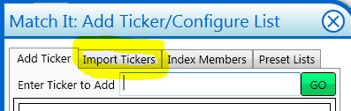
Now just paste all the tickers that you want on the list into the box, with a new line between each one, and hit IMPORT.
You can also use this approach to quickly set your list to a very short one of only one or two tickers.
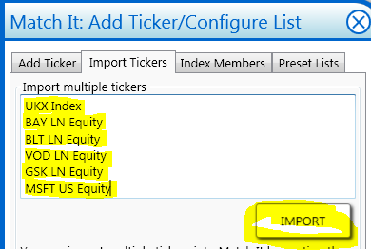
After you hit Import you will see the following dialog:
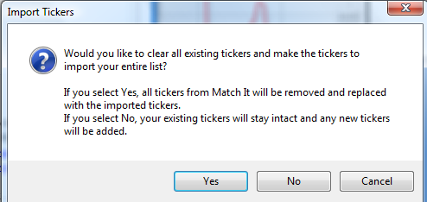
Here you have the option of replacing all your Tickers with just the pasted ones by selecting Yes, or adding the pasted tickers into your list by selecting No.
The idea is interesting, but I don’t see any evidence that it’s accurate?
This question is quite difficult to answer, because by its very nature the app is open ended on what tickers and asset classes it can be used for. All we can really do is recommend you use the functionality available within Match It to investigate your own specific situation. In particular:
The accuracy of Match It will depend on the data that you’re Matching against. It might be best to use a set of tickers that you feel are related, or likely to show similar behaviour.
The more data Match It has available, the closer the historical Matches you’re likely to find will be.
You can use the “Zoom” button at the top right of the chart to see how accurate Match It has been at an historical date. If you think the market is similar generally to how it’s been on a date in the past, why not run on that date to see how accurate it was then?

When you click on “Zoom” you will be prompted to enter a date. If you want to see how accurate Match It was on the 1st Jan 2011 for example, enter that date in the dialog and press OK. When you run your next Match, Match It will only use data up to the 1st Jan 2011, and in addition, it will match against the chart that was visible on that day. This means that you can see for yourself if Match It was accurate on that date or not.
We do also provide more complete Back-testing, in the terms of a day by day analysis, but it is extremely slow. Please email and ask if you would like backtesting data for a specific Match.
If I have any questions, who should I ask?
You can usually get in touch with us in online chat via IB – type in IB HELPDESK PERCENTAGEIT<GO> into your terminal.
We can be reached by email or MSG at helpdesk@percentageit.com
You can also call us at +44(0)203 397 2 398

