What does Match It do?
Match It says, “if we have this chart today, and we have so much historical data available to us these days, surely we’ve seen charts that looked similar to it before? Tell me what happened to those charts.”
You can select any ticker available on Bloomberg, from any asset class, and any of the available timeframes at the top right. Match It will then look to find charts in the past that look “similar” to the chart you have selected.
In the example below, the current chart at the top right shows the BLT LN Equity Ticker, on the last 2 hours Timeframe. When you click on Match It, Match It will search all historical data on the tickers on the list to the left, looking for charts that look similar to the current chart.
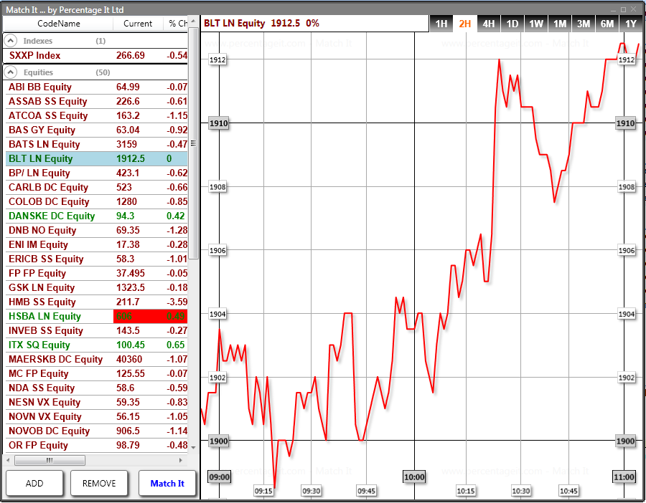
Match It allocates each historical chart (or “Match”) a score out of 100%, for how similar the chart is to the original data, and only the best 50 results by this score are returned at all.
It’s best to think of the allocated score in a similar way to correlation, which is a large contributing factor in fact. Many people use correlation of two tickers today, the difference with Match It is that we’re looking for all correlation against tickers in the past. Every price bar on the visible chart is used for the correlation calculation, and no more. If you’re viewing a year’s worth of data on the chart, then Match It will look at each individual year span from the historical data of each ticker.

How to read the Matches screen
Match It will jump to the summary screen for the best 8, but we’re going to look at the Configuring Matches screen next. This screen lists each of the best 50 Matches from the past, listing the ticker whose price history it came from, the score it was allocated out of 100, and the date and time of when the Match occurred.
By default Match It includes the top 8 Matches by score in its results screen (they’re included because of the check next to them), but you can use this screen to change which Matches are included, or indeed to investigate the Matches more closely.
The red line on the Matches screen is the original data. Each blue line corresponds with one of the selected Matches. Click on one to display which it is on the list. They extend beyond the original data because they occurred in the past, and Match It will use this extension beyond the data to provide the probability bands in the result screen.
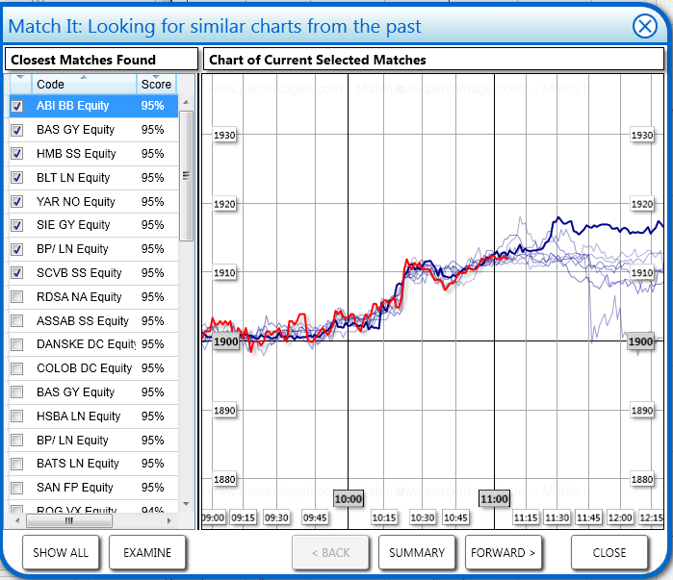
Using the Examine button will clarify exactly what we mean by a Match. If we select the first Match from the list above – ABI BB Equity, 95%, 1st Oct 2012 15:21 and then hit Examine, we receive the following chart:
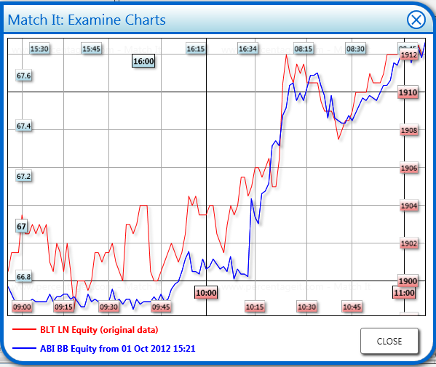
The legend at the bottom shows the two sets of data, the original data in red, and the Matched historical data in blue.
Because the Matched data is historical, and potentially at a different price level, we use an independent X and Y scale for each data set. Consequently, you can see the original data’s date or time scale in red at the bottom, and the Matched data’s date or time scale in blue at the top. The colours on the axis labels indicate which data set the level corresponds to. The grid lines drawn are all based on the original data.
In this example, Match It is set to look on the same time scale for Matches. The original data shows between 9am and 11am today, whereas the Matched data starts at 15:21 on the 1st October, but the amount of data shown will still be two hours worth. On the left hand side you will see the prices match the historical prices, whereas on the right hand side they match the original data. Match It can be set to compare charts from different time scales, in which case the screen will change accordingly.
It’s up to you which results you include. Sometimes you see a very dramatic drop or rise in a single ticker and this can skew the later results. It may be worth excluding this, or you just not want to include results from one of the tickers.
Once you’re happy with the Matches you’ve selected, you can hit Summary to get a probability band breakdown of future price action.

How to read the Summary screen
The summary screen uses the fact the Matches selected were in the past, and we know what happened next for them, to show probability bands going forward. If the current price chart behaves similarly to how the charts in the past behaved, you would expect the probabilities to hold this time as well.
The chart extends forward in time along the X axis, so as you go right you go further forward. The Y Axis represents percentage change from the price at the end of the original data.
There are three summary boxes at the bottom which give short term at-a-glance descriptions of what you see on the chart.
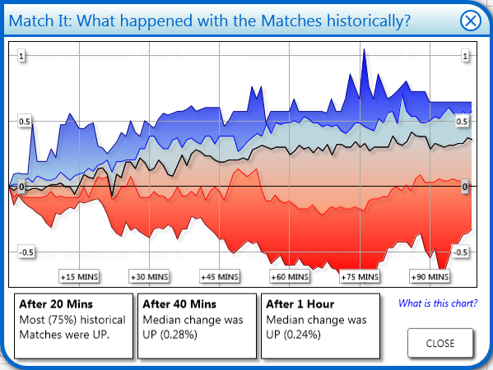
Each band on the chart represents a quarter of the data. We extend 1, 2, 3... bars past the Matched data area, and we record the percentage change for each Match. We then order those Matches, and the top quarter make up the dark blue bands range, the next quarter the paler blue bands range and so on.
Because this is done on a bar by bar basis, the Matches which make up the top quarter might change bar by bar as well – Match It will literally look at the top quarter percentage changes and not investigate in detail where they came from.
If the topmost area of the topmost blue band hits 10% after 20 bars, that means that the most the price had gone up by in percentage terms after 20 bars in any of the historical Matches was 10%.
There are a lot of things that are interesting about this screen. It can give you an estimate of the probability that levels will be hit, and also how quickly they will be hit. It can provide you with situations where there has been a high probability of a certain event happening historically (when three bands are very tight together), or when there has been a directional bias historically (eg all three bands above or below the 0% change line).
It can also give you an idea of what the risk associated with a holding might be – for example in the picture before, the 25% probability line touches the zero line quite a lot – so we’re looking at generally speaking 75% of historical Matches having low risk, and those extreme 25% don’t go much lower than a risk of -0.5%.
As well as the probability bands displayed, there is a thick black line which represents the “Median” line, or middle result. If this moves in a strong trend it is also a sign that historically there has been a pattern in the data.
If you get a very wide dark blue upper band, or a very wide dark red lower band, this tends to mean that the results are skewed by an extreme riser or faller in the past. It may be worth excluding this from the Matches screen and coming back to the summary screen.
You won’t always see meaningful data on this screen. Statistically if you had no meaningful information, you would expect to see a chart that opens out gradually from left to right, that is centred on the zero axis.

Any more questions
If you have any more questions, would like us to talk you through the app on the phone, or on messaging via Instant Bloomberg, please let us know.
We can be reached on IB by typing “IB HELPDESK PERCENTAGEIT”
Or on email by sending to helpdesk@percentageit.com

